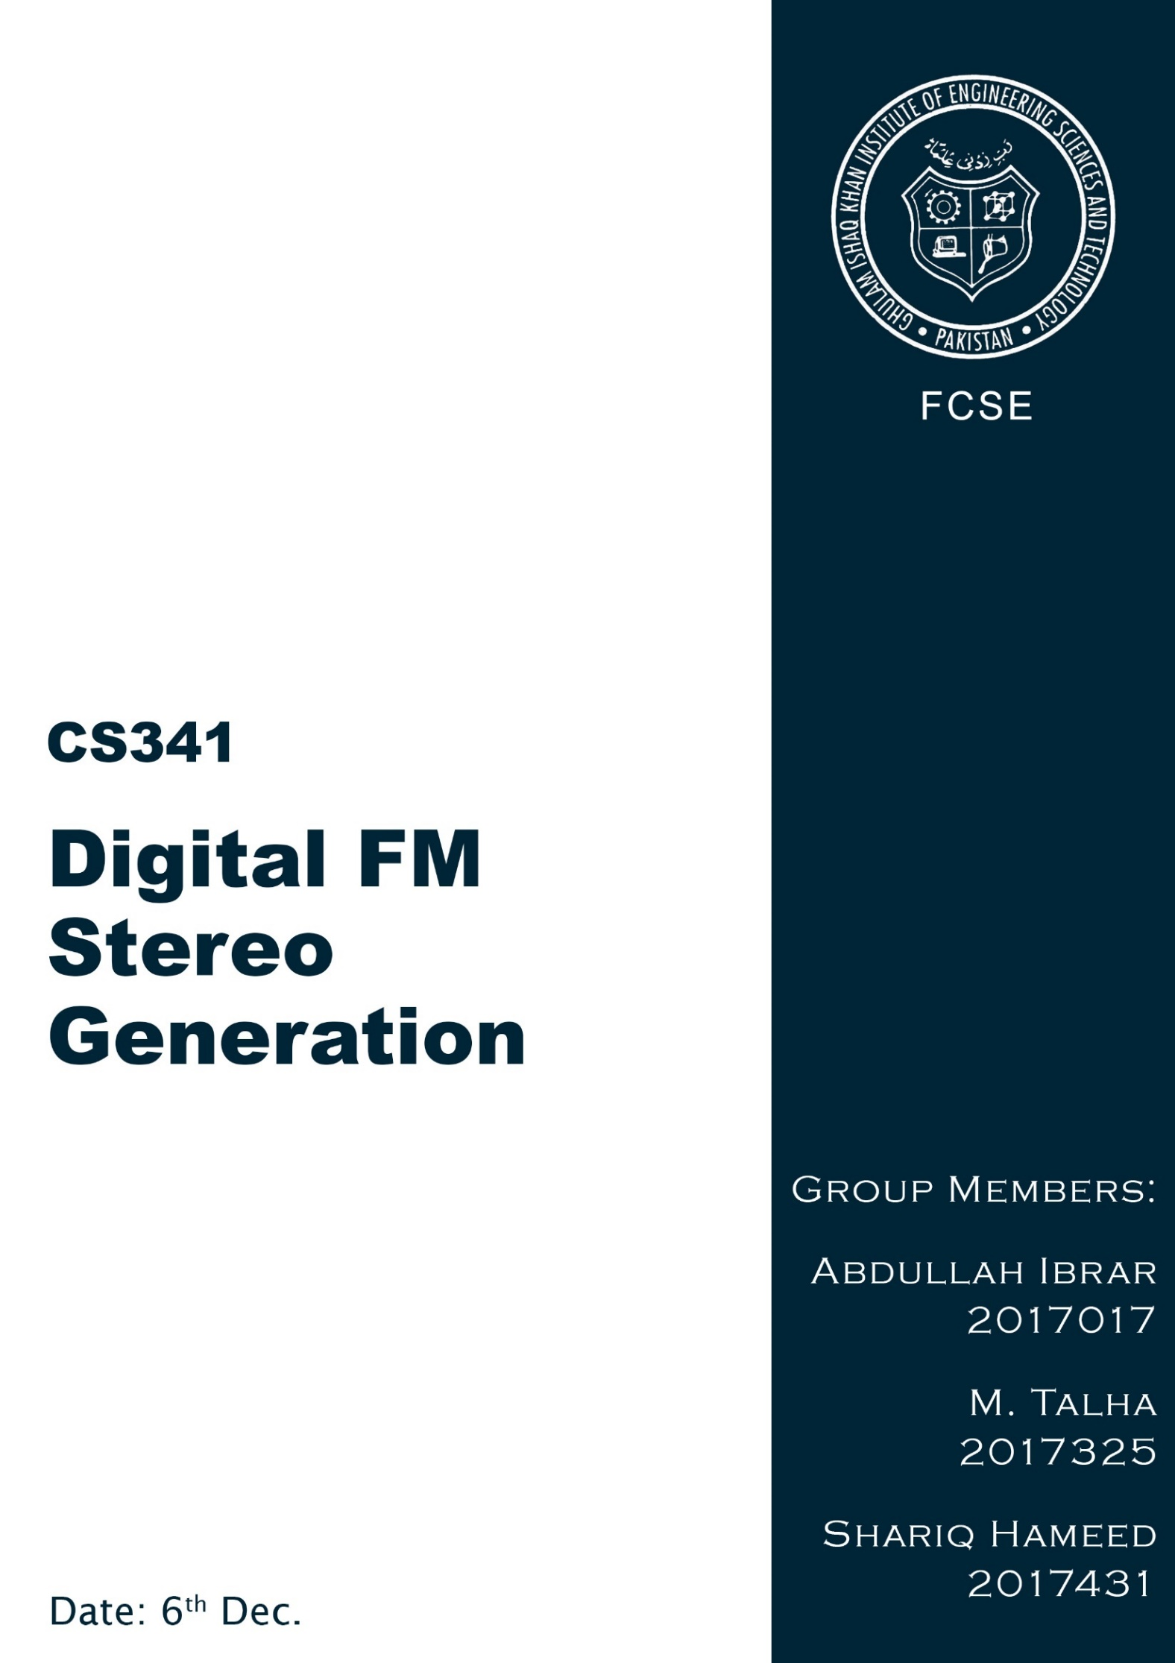

Table of Contents

Digital FM Stereo Generation 3

Problem 3

Introduction 3

Method 4

MATLAB Code 5

Results 6

Conclusion 7

References 8

# Digital FM Stereo Generation

# Problem

Design an FM-Stereo generator device that uses a complex modulation system, to achieve a compatible mono/stereo system of broadcasting.

# Introduction

FM Stereo broadcasting was introduced during the early 1960s.The FM stereo system uses a complex modulation system to achieve a compatible mono/stereo system of broadcasting. Essentially, the system performs the **multiplexing of two audio signals** and further combines them into a **complex baseband signal that modulates the FM carrier**.

The system works by broadcasting a sum of the left (L) and right (R) audio channels, a pilot tone of 19 kHz and a double sideband suppressed carrier (DSBSC) sub-channel that contains the difference of the two audio channels.

FM-stereo generator using **mixed digital and analogue techniques**. We use Direct Digital Synthesis (DDS) for [*carrier and pilot tone generation*](https://www.circuitlib.com/index.php/tutorials/product/42-how-to-build-an-fm-stereo-generator#DDS_Generator), an analogue [*balanced modulator*](https://www.circuitlib.com/index.php/tutorials/product/42-how-to-build-an-fm-stereo-generator#Balanced_Modulator), based on the well known MC1496, for the generation of the sub-channel and an accurate op-amp based, [*matrix*](https://www.circuitlib.com/index.php/tutorials/product/42-how-to-build-an-fm-stereo-generator#The_Matrix).

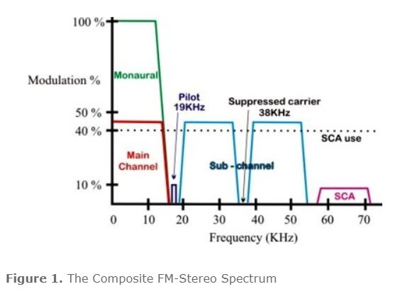

# Method

In a simple monaural system, the FM channel is frequency modulated ±75KHz with the audio information and the monaural audio signal occupies the 0-15KHz spectrum of the transmitted frequency spectrum. When stereo is transmitted, the same monaural signal (left plus right channel combined) remains in the 0-15KHz spectrum of the FM stereo signal and an additional sub – channel, centered at 38 KHz, which is a double sideband suppressed carrier signal (DSBSC) is transmitted. This subcarrier is a left-subtracted-from-right (L-R) signal, which, when fed threw a matrix with the monaural main channel on the receiver, forms the individual left and right channels. An additional pilot career signal at 19 KHz is also transmitted. The pilot signal is phase-coherent (synchronized), to the suppressed 38 KHz carrier.

In a FM-stereo system, the monaural signal is modulated about 45%, the sub channel and the pilot tone are modulated 45% and 10%, respectively, so that the total modulation for a stereo FM- station is 100%. In modern stations where some SCA or RDS/RBDS subcarriers are also used, the modulation of the main and the sub channel are furthermore reduced in order to the total modulation being kept less than 100% (±75KHz deviation).

In an FM-stereo receiver the 19 KHz pilot indicates that the transmission is stereo. The receiver regenerates the 38 KHz carrier and then uses coherent detection for the sub-channel. Coherent detection only works when the carrier is present at the receiver. Off course, the receiver cannot obtain the 38 KHz carrier from the baseband signal directly (because the carrier is suppressed during transmission). The carrier is actually obtained in the receiver from the 19 KHz pilot signal.

Both the left and the right audio channels are pre-emphasized, just as normal monaural signal would be. Then, the left and the right signals are both added and subtracted on a matrix. The audio signals added (L+R), form the monaural signal which is the main channel. The subtracted signals (L-R) are modulated on a 38 KHz carrier, to form the sub-channel. Since a balanced modulator is used, the carrier at 38 KHz will be suppressed, leaving only the modulated audio information. The 38 KHz oscillator is divided by 2 to produce the coherent 19 KHz pilot signal. Both the carrier and the pilot signal should be purely harmonics (sinusoidal), otherwise some undesirable (spurious - noise) signals may appear in the composite spectrum.

The three components of the stereo signal, i.e. the main channel, the sub channel and the pilot tone, are combined at the proper ratios (45%, 45%, 10%), forming the composite output.

# MATLAB Code

clc;

clear;

close all;

noCh = 1; % number of channels, not important at the moment, just use 1

Fs = 400e3; % sampling frequency

bw_rx = 200e3; % receiver bandwidth (not being used atm)

i_t = 1; % integration time is always 1 second during FM signal generation

[data, Fs_data] = audioread('sound.mp3'); % music data

t = linspace(0, i_t, Fs*i_t); % time vector

st = zeros(noCh, Fs*i_t);

for k=1:noCh

l = transpose(data(1e5+1:1e5+Fs_data, 1)); % left channel data

r = transpose(data(1e5+1:1e5+Fs_data, 2)); % righ channel data

l = resample(l, Fs*i_t, Fs_data*i_t); % interpolate to Fs for shifting in frequency domain

r = resample(r, Fs*i_t, Fs_data*i_t);

l = l/max(l); % normalize

r = r/max(r);

figure

subplot(2,1,1)

% message signal

mt = 0.5*(l+r) + 0.5*(l-r).*cos(2*pi*2*19000*t) + 0.5*cos(2*pi*19000*t);

mt = mt/max(mt);

temp = abs(fft(mt))/max(abs(fft(mt)));

% plot the message signal

plot(20*log10(fftshift(temp)))

% integration and multiplication with 2*pi*75000

mt = 2*pi*75000*cumsum(mt);

st(noCh, :) = cos(mt) + 1i*sin(mt); % complex envelop stereo FM signal

end

subplot(2,1,2)

% plot the complex envelope signal

plot(20*log10(fftshift(abs(fft(st))))

# Results

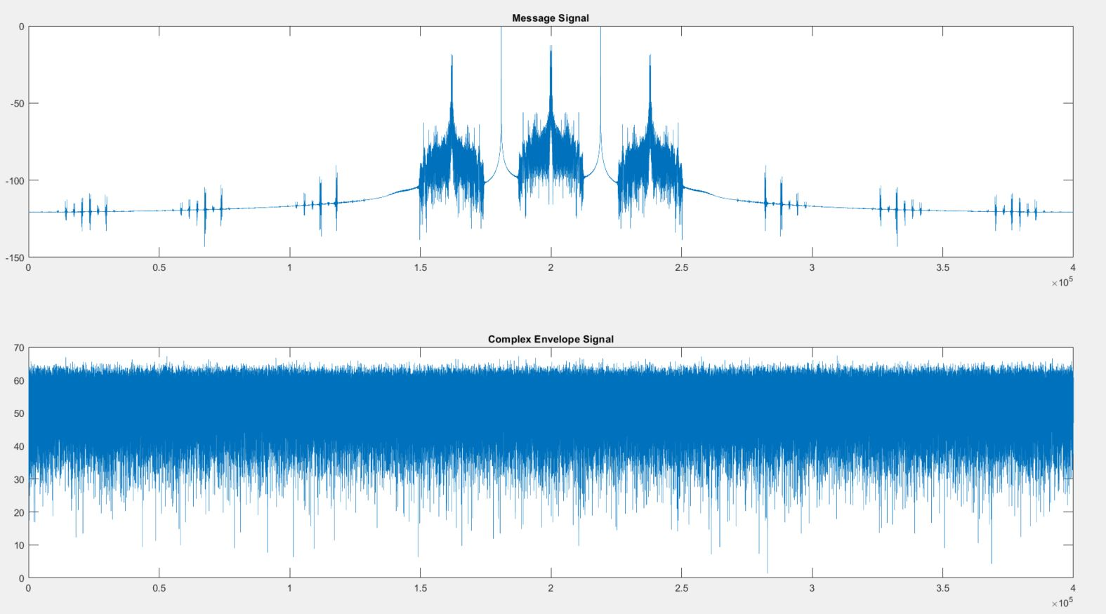

# Conclusion

We have successfully generated digital FM Stereo device. The complex modulation and resultant compatible mono/stereo system of broadcasting has many practical applications as well which can be very useful in daily life. The generator can meticulously be used for **commercial radio broadcasting**

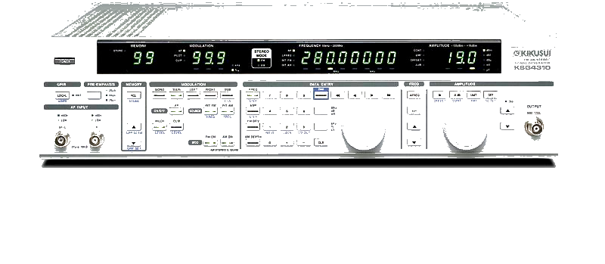

# References

* James D. Broesch: *Digital Signal Processing Demystified*, Newnes, [ISBN](https://en.wikipedia.org/wiki/International_Standard_Book_Number) [1-878707-16-7](https://en.wikipedia.org/wiki/Special:BookSources/1-878707-16-7)
* Stranneby, Dag; Walker, William (2004). [*Digital Signal Processing and Applications*](https://books.google.com/books?id=NKK1DdqcDVUC&pg=PA241) (2nd ed.). Elsevier. [*ISBN*](https://en.wikipedia.org/wiki/International_Standard_Book_Number) [*0-7506-6344-8*](https://en.wikipedia.org/wiki/Special:BookSources/0-7506-6344-8).
* Vijay Madisetti, Douglas B. Williams: *The Digital Signal Processing Handbook*, CRC Press, [ISBN](https://en.wikipedia.org/wiki/International_Standard_Book_Number)
* [James H. McClellan](https://en.wikipedia.org/wiki/James_H._McClellan), [Ronald W. Schafer](https://en.wikipedia.org/wiki/Ronald_W._Schafer), Mark A. Yoder: *Signal Processing First*, Prentice Hall, [ISBN](https://en.wikipedia.org/wiki/International_Standard_Book_Number) [0-13-090999-8](https://en.wikipedia.org/wiki/Special:BookSources/0-13-090999-8)
* John G. Proakis: *A Self-Study Guide for Digital Signal Processing*, Prentice Hall, [ISBN](https://en.wikipedia.org/wiki/International_Standard_Book_Number) [0-13-143239-7](https://en.wikipedia.org/wiki/Special:BookSources/0-13-143239-7)
* Van De Vegte, Joyce (2001). Fundamentals of Digital Signal Processing. Prentice Hall. [*ISBN*](https://en.wikipedia.org/wiki/International_Standard_Book_Number) [*0-13-016077-6*](https://en.wikipedia.org/wiki/Special:BookSources/0-13-016077-6).
* Oppenheim, Alan V.; Schafer, Ronald W. (2001). Discrete-Time Signal Processing. Pearson. [*ISBN*](https://en.wikipedia.org/wiki/International_Standard_Book_Number) [*1-292-02572-7*](https://en.wikipedia.org/wiki/Special:BookSources/1-292-02572-7).
* Doug Smith: *Digital Signal Processing Technology: Essentials of the Communications Revolution*, American Radio Relay League, [ISBN](https://en.wikipedia.org/wiki/International_Standard_Book_Number) [0-87259-819-5](https://en.wikipedia.org/wiki/Special:BookSources/0-87259-819-5)
* Charles A. Schuler: *Digital Signal Processing: A Hands-On Approach*, McGraw-Hill, [ISBN](https://en.wikipedia.org/wiki/International_Standard_Book_Number) [0-07-829744-3](https://en.wikipedia.org/wiki/Special:BookSources/0-07-829744-3)